|  |  |  |
| --- | --- | --- |
| Basketball years 7 and 8 This league also has graded divisions to ensure the top teams do not play against the newer teams.   * All of the rules of Basketball are called in this league including the 3 second rule. This is when an attacking player is in the shooting key for more than 3 seconds without moving out of the key with both feet, therefore gaining an unfair advantage for their team. * Teams also have only 8 seconds to dribble or pass the ball over the halfway line. * No zonal defenses are allowed in this league. * Individual and team fouls are called and recorded by our Referees. * When taking free throws in this league, the player must not jump and land over the free throw line before the ball hits the hoop. * We begin the game with a toss, thereafter it is alternate possession. For any unsighted ball, alternate possession applies. * We support parents/coaches cheering from the sideline (only positive comments please). |  | Basketball years 9-11 This league also has graded divisions to ensure the top teams do not play against the newer teams.   * All of the rules of Basketball are called in this league including the 3 second rule. This is when an attacking player is in the shooting key for more than 3 seconds without moving out of the key with both feet, therefore gaining an unfair advantage for their team. * Teams also have only 8 seconds to dribble or pass the ball over the halfway line. * No zonal defenses are allowed in this league. * Individual and team fouls are called and recorded by our Referees. * When taking free throws in this league, the player must not jump and land over the free throw line before the ball hits the hoop. * We begin the game with a toss, thereafter it is alternate possession. For any unsighted ball, alternate possession applies. * We support parents/coaches cheering from the sideline (only positive comments please). |

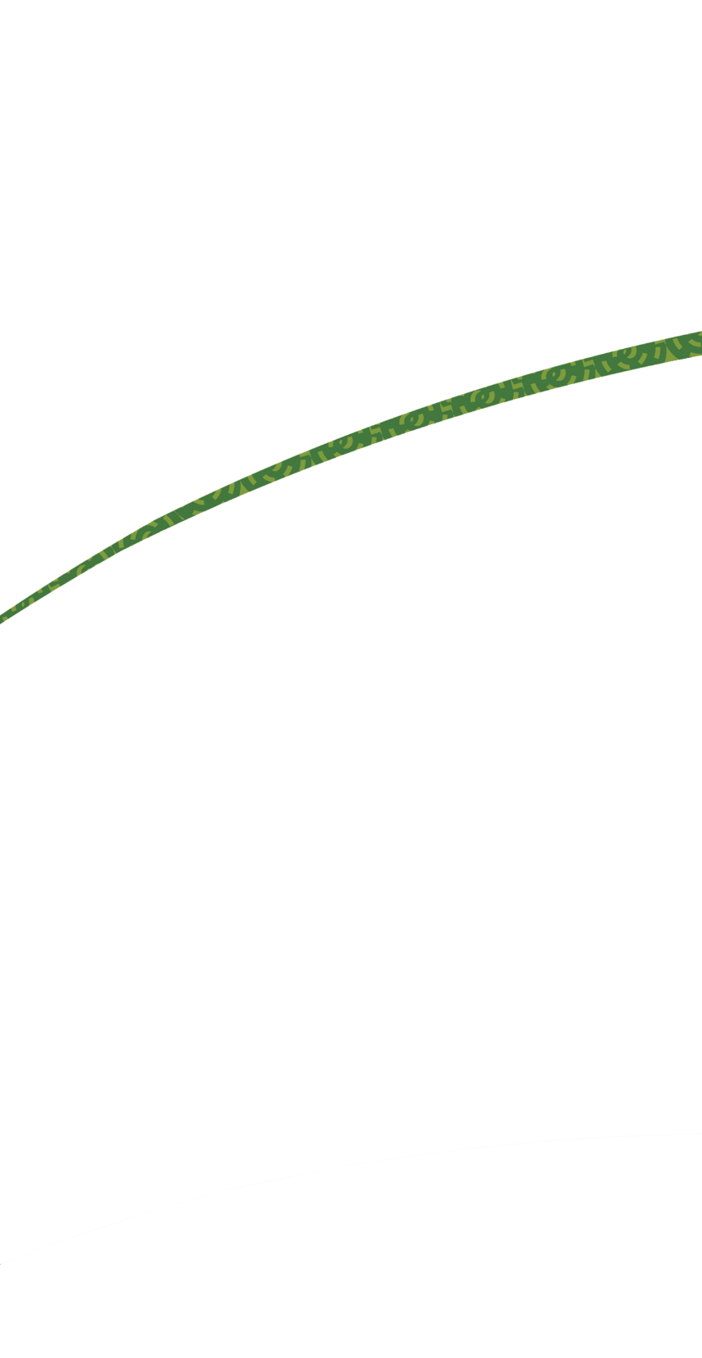Miniball and Basketball Guidelines

Stanmore Bay Pool   
and Leisure Centre

|  |  |  |  |  |
| --- | --- | --- | --- | --- |
| Phone 09 424 9227 or visit **aucklandleisure.co.nz** |  |  | Phone 09 424 9227 or visit **aucklandleisure.co.nz** |  |

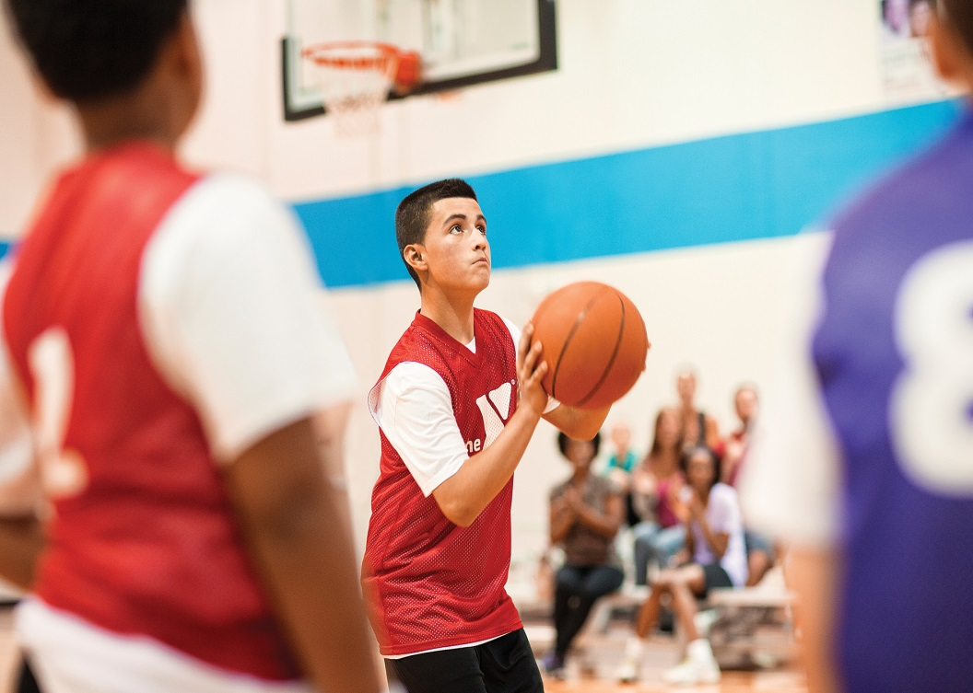

|  |  |  |  |  |
| --- | --- | --- | --- | --- |
| Miniball years 1-4 This league is designed to give children the basic skills required to play basketball but still have fun. We have graded sections so it is fair for everyone.     * It is played on a full size basketball court but on lower hoops. These hoops are 2.4m (7ft 9in) in height. * Each goal, regardless of where on the court it is scored from, is counted as 1 point. * Children are encouraged to steal the ball from the opposition without fouling (touching) their opponents. * Children must bounce the ball with one hand only and double dribbles are called as a violation (a double dribble is when a player has caught the ball, dribbled, then re-caught the ball and dribbled again). * Our referees will encourage the children to bounce, pass or shoot the ball whilst encouraging the opposition to keep their hands up to try to prevent a pass. * Referees will also encourage the children to use their pivot foot so they do not travel. A pivot is when the player keeps their landing foot on the ground and turn using their other foot. * A travel is when the landing foot is re-grounded before the ball is dribbled or passed. * No zonal defenses are allowed in this league. * We support parents/coaches cheering from the sideline (only positive comments please).   MPj04225230000[1] |  | Basketball years 5 and 6 This is the first time teams will play ‘proper’ basketball. They will play on a full size court with hoops at the regulation 3.05 metres (10 feet).  We have graded sections in this league, which  negates top teams playing against new teams.   * Points are scored as 2 points, 3 points if scored from outside the 3 point line and 1 point for each  successful free throw. * Players must bounce the ball with one hand only and double dribbles are called as a violation. * The back court rule is in operation. Back court means a player must have 3 x points (2 feet and the ball) over the half way line and then move back into the other side of the court for a violation to be called. * Players must have a number on their shirt whilst playing. Stanmore Bay Pool and Leisure Centre has numbered bibs which can be used if teams do not have a numbered uniform. * Individual fouls are also called on players. This means that a player cannot have more than 5  individual fouls in a game. Once a player has 5  individual fouls they cannot take any further part in the game that night but can be replaced by another player from their own team. Our Referees will notify the player when they have reached 4 fouls. * Free throws are also taken in this league when the defending team foul an attacking team member in the act of shooting or when a team has reached 7 team fouls in one half of the game. Team fouls are collated with each individual foul. * The ball must hit the hoop when a free throw is taken or the opposition receives the ball from the sideline, in line with the free throw line. * The 5 second rule is also in play (this is when a closely guarded player must release the ball within 5 seconds) or when the ball is being thrown in from the sideline or baseline. |  | Basketball years 5 and 6 cont…  * Players are asked to go back to halfway and remain there after scoring to enable the team with the ball to pass amongst their team and get the ball over the halfway line. * No zonal defenses are allowed in this league. * To deliberately kick the ball or strike the ball with a closed fist is a violation. Kicking means striking the ball or blocking it with the knee, any part of the leg below the knee or foot. If the ball strikes the foot or leg accidentally it is not a violation. * Our referees will encourage players to play as a team, passing and moving up and down the court. * We support parents/coaches cheering from the  sideline (only positive comments please).     MPj03994480000[1] |

